**Microservices with Spring Boot 3 and Spring Cloud HandsOn**

Creating Microservices for account and loan In this hands on exercises, we will create two microservices for a bank. One microservice for handing accounts and one for handling loans.

🡪Step-1:Downloading the zip file from spring initializer

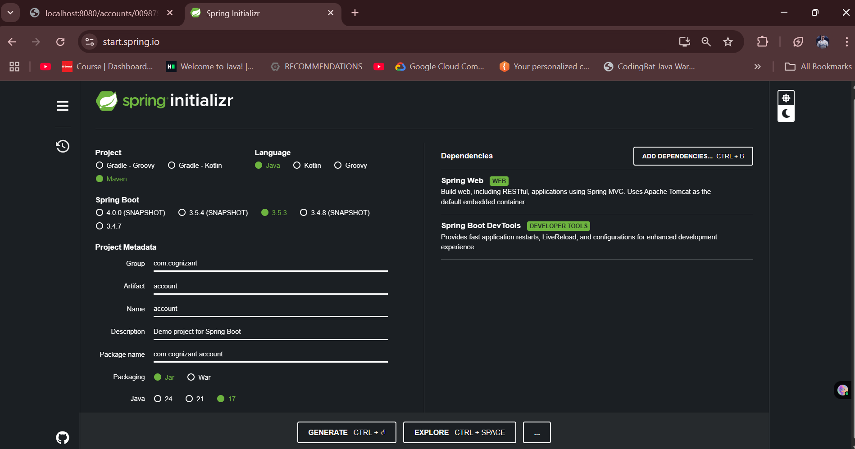

Step-2:Importing the zip file after extraction

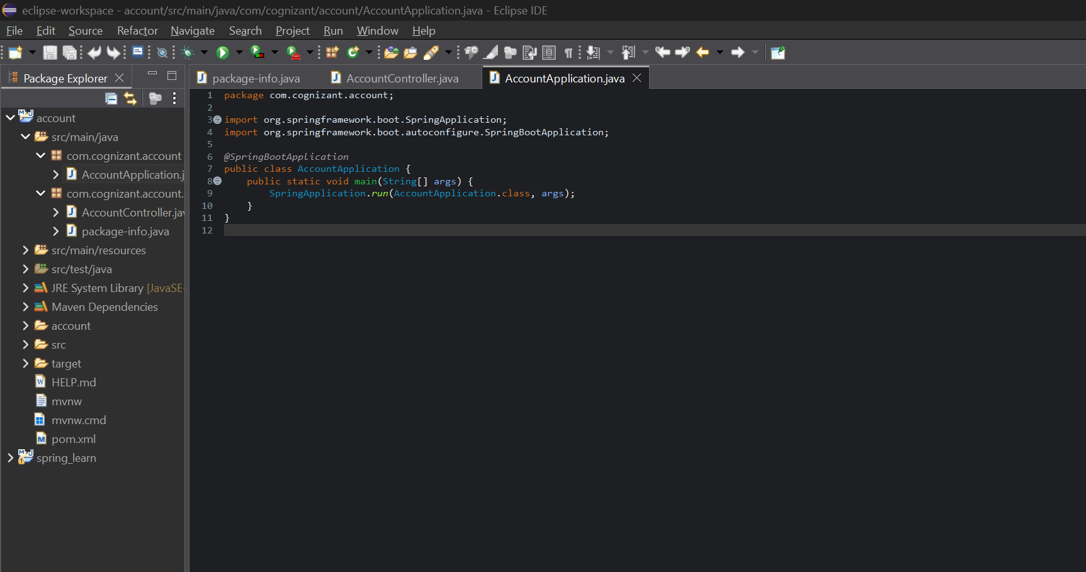

MICROSERVICE 1

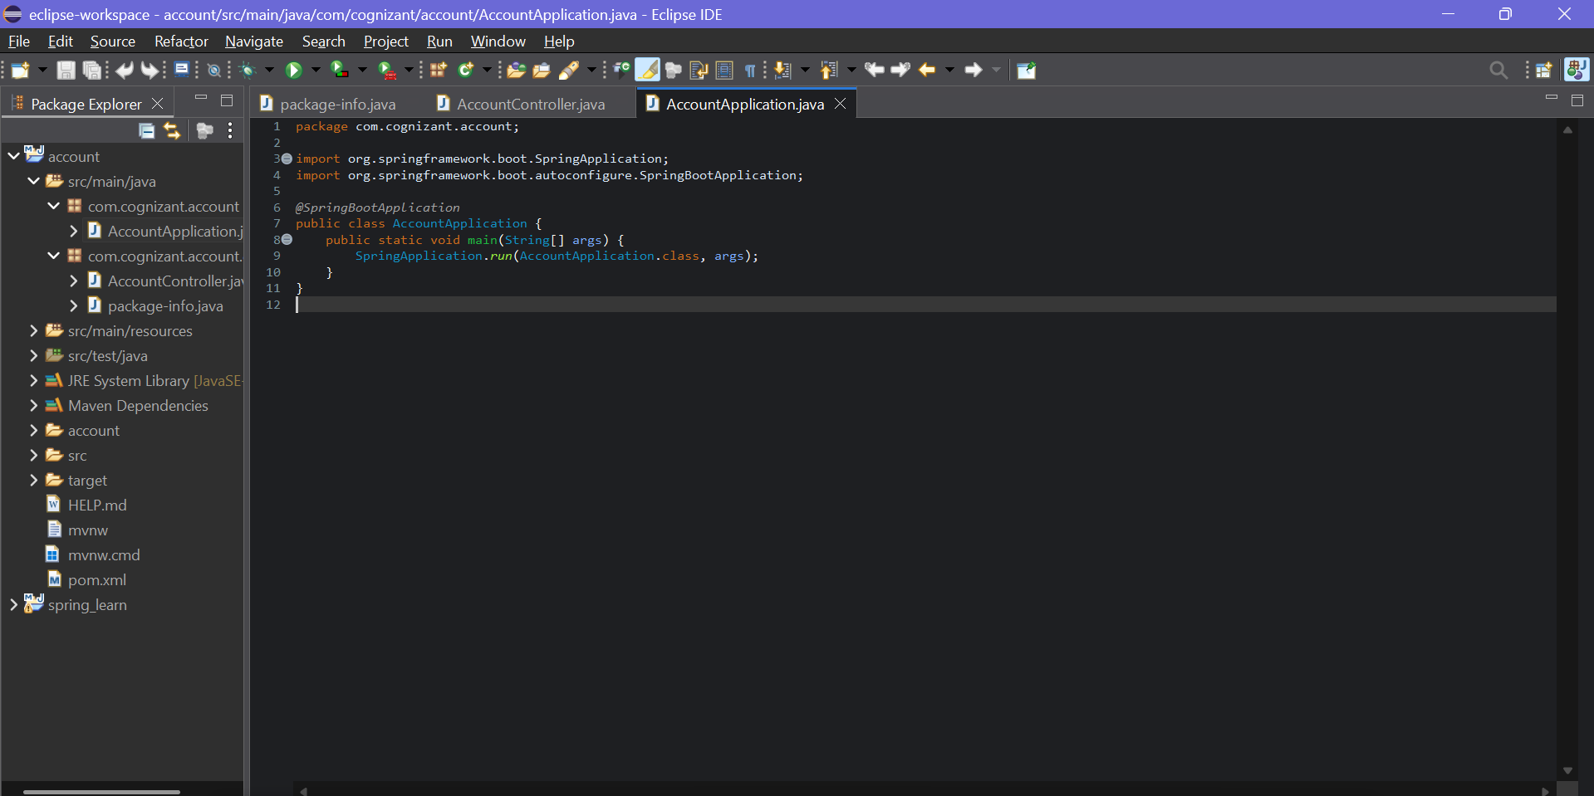

Running the code

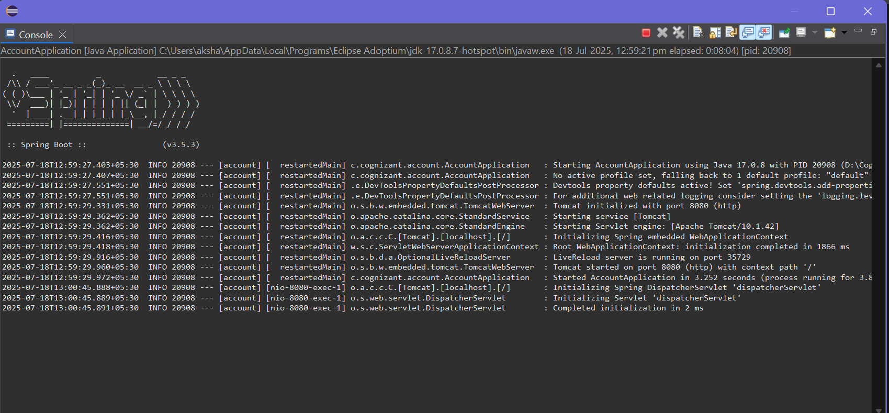

Testing in the browser

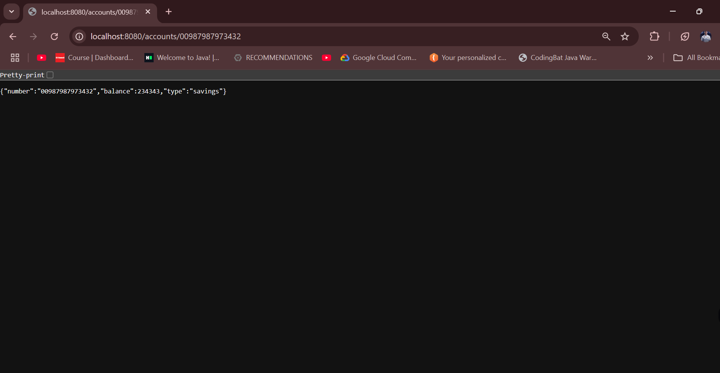

MICROSERVICES 2:Loan

a)Downloading the necessary depends using Spring Initializer

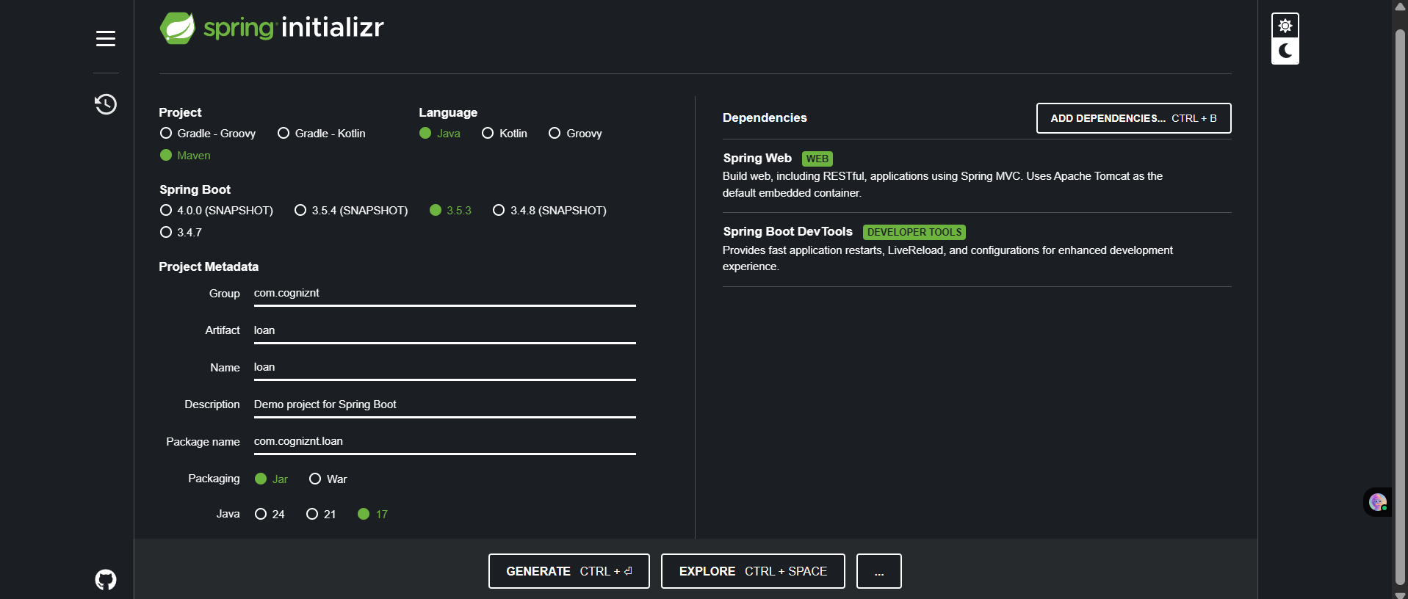

b)Extracting it and using mvn clean package in command prompt to build the project

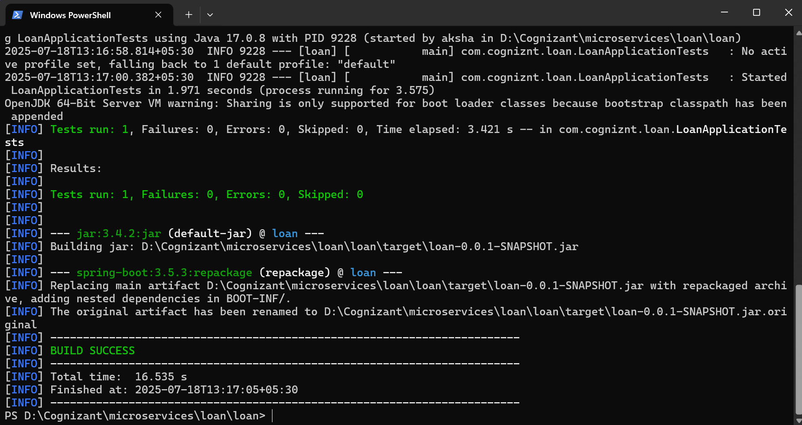

c)Importing the project in Eclipse

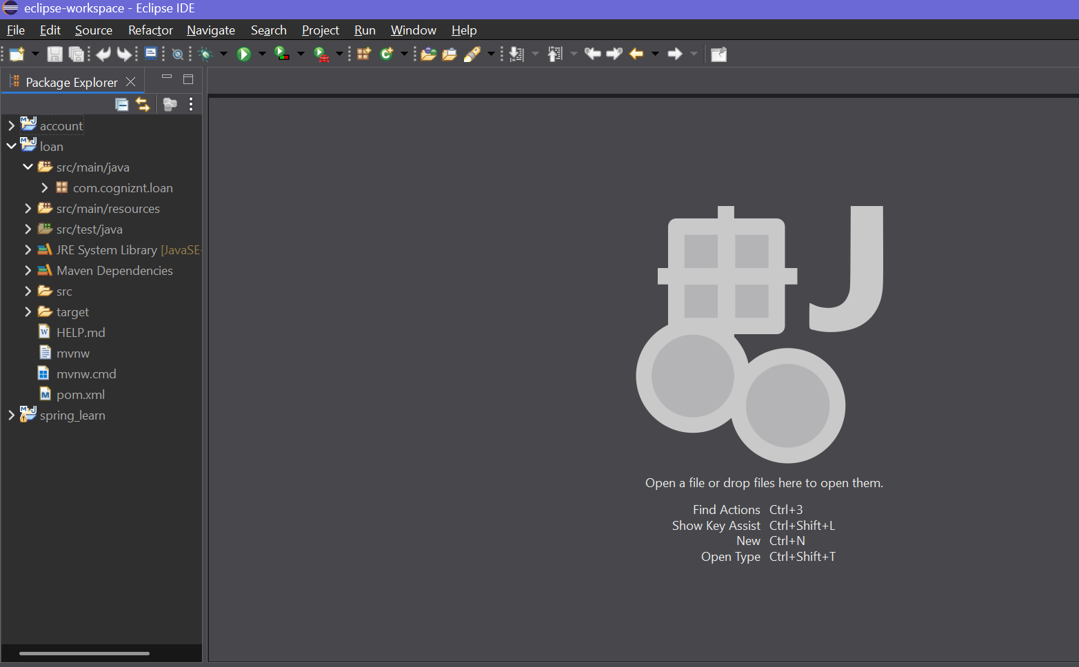

d)Setting port to avoid conflict (by default the port is running on 8080 so setting the loan at 8081)

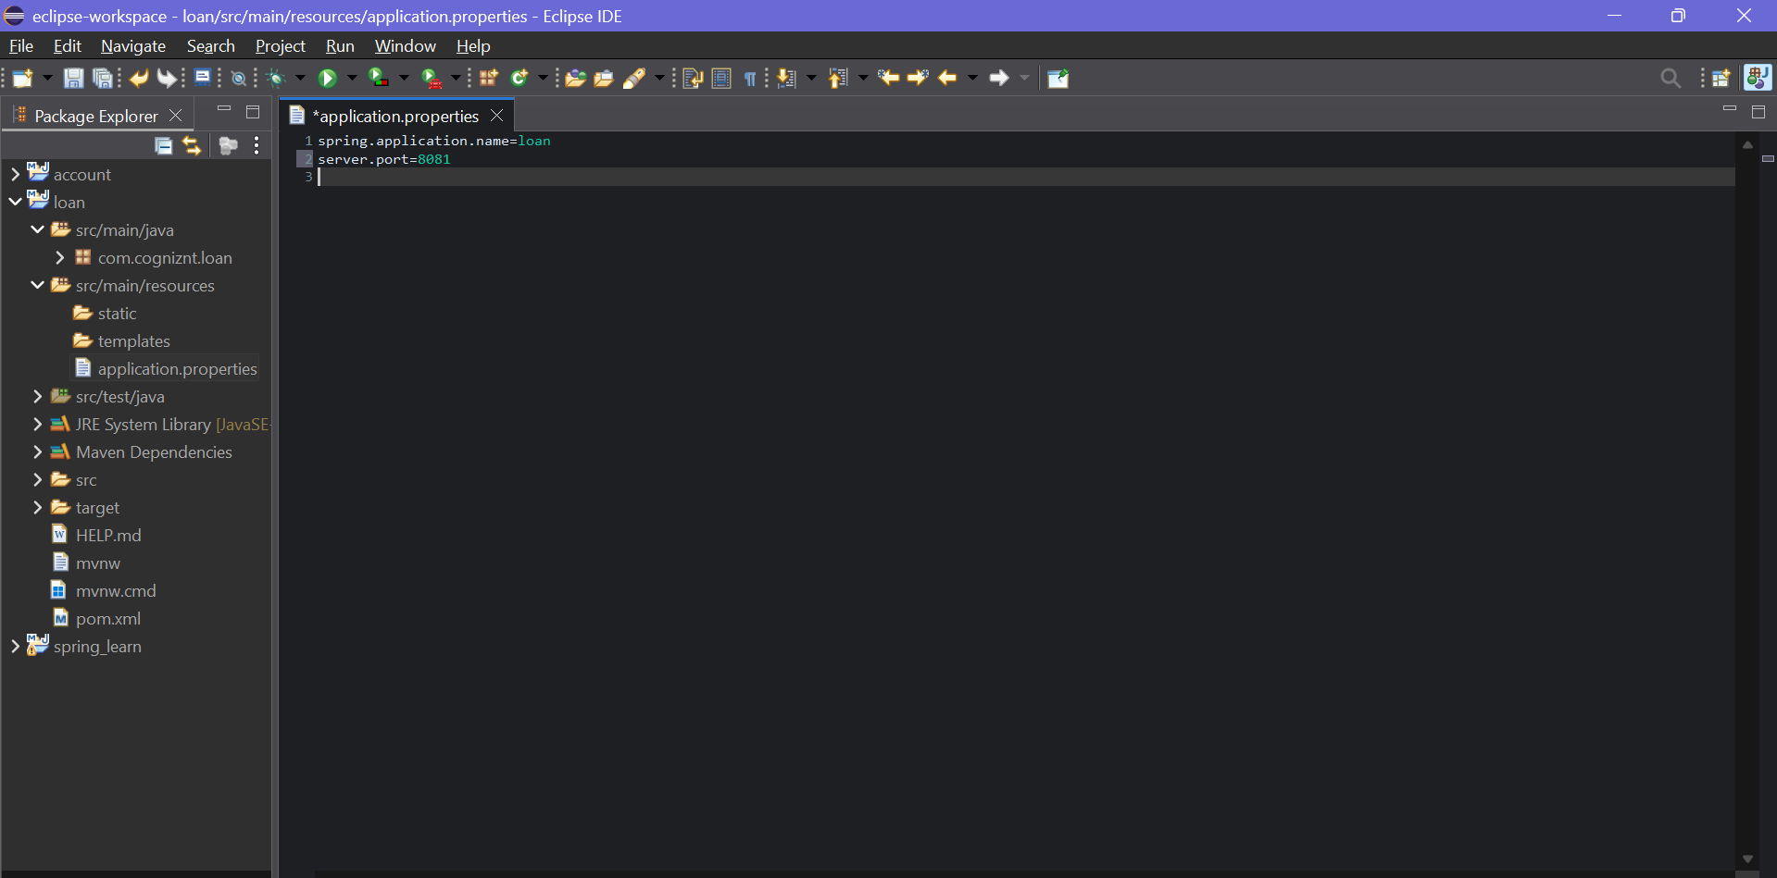

e)Creating the loan Controller

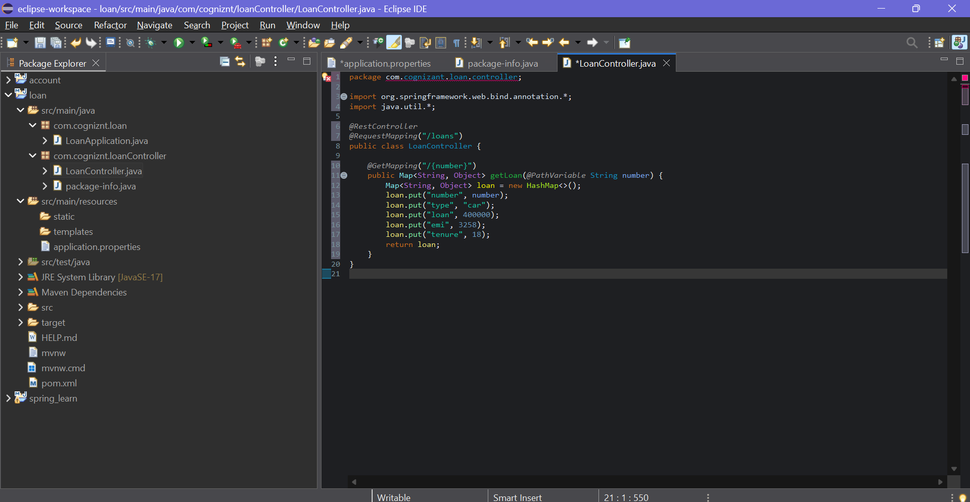

f)Running the loan Microservice

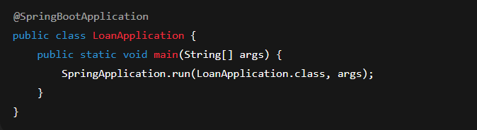

g)Testing it on the browser



